Unit 1 –Class Fundas (Part 1)

Q-1: History of Java (Simple Answer)
- Java is an object-oriented programming language.
- It was developed by James Gosling in the early 1990s.
- At first, Java was made for electronic devices like TV and set-top boxes.
- Before Java, C++ was considered, but it was not used because it needs more memory and uses pointers (complex).
- James Gosling and his team created a new language called “Green Talk”, which was later named “Oak”.
- The name Oak was changed to Java because the name Oak was already used by another company.
- The name Java comes from coffee (espresso beans).
- Java was designed with important features:
  - Portable
o Strong (robust)
o Platform independent o High performance
o Multithreading
- Today, Java is used in:
  - Internet programming o Mobile apps o Games
  - Business applications
- Many versions of Java were released like:
  - JDK Beta
- JDK 1.0
o JDK 1.1
  - J2SE 1.3, 1.4

Short Exam Tip (2–3 lines)
Java is an object-oriented language developed by James Gosling in the 1990s.
It was first called Oak and later renamed Java.
It is widely used for web, mobile, and business applications.

Q-2: Features of Java (Simple Answer) Java has many important features:

- Simple
  - Java is easy to learn.
  - It uses syntax like C/C++.
  - It does not use pointers → makes it simple.

- Security
  - Java is very secure.
  - It helps to create virus-free programs.
  - Security features:
    - No pointers o Runs inside JVM (safe environment)

- Portable
  - Java program can run on any system.
  - You can move code from one OS to another.
Example: Windows → Linux → Mac

4️ Object-Oriented (OOP)
  - Java follows OOP concepts.
  - It makes programs easy to manage.
Main concepts:
  - Class
  - Object
  - Inheritance
  - Polymorphism
  - Abstraction
  - Encapsulation

5️ Robust (Strong)
  - Java is strong and reliable.
  - Features:
    - Good memory management o No pointers o Automatic garbage collection (removes unused data)

6️ Multithreading
  - Java can do many tasks at the same time.
Example: Download + play music together
  - Saves memory because threads share memory

7️ Architecture Neutral
  - Java works the same on all systems.
  - Data types size is fixed.
Example: int is always 4 bytes

8️ Interpreted
  - Java is both compiled and interpreted. Steps:
  - Compiler → converts code to bytecode // a.java →javac a.java → a.class (bytecode)
  - JVM → converts bytecode to machine code // run “a.class” file when program will fun

9️ High Performance
  - Java gives good performance.
  - No pointers → faster execution
  - Uses efficient memory system

Dynamic
  - Java loads classes when needed.
  - Supports dynamic memory and updates

Short Exam Tip (Very Important)
Java is simple, secure, portable, and object-oriented language.
It supports multithreading, high performance, and platform independence.
Q: Explain Java Editions (Simple Answer) Java has 3 main editions:

- ⃣ Java Platform, Micro Edition (J2ME)
  - J2ME stands for Java 2 Platform Micro Edition
  - It is used for small devices
Examples:
  - Mobile phones (feature phones)
  - Set-top boxes
  - It was developed by Sun Microsystems

- Java Platform, Enterprise Edition (J2EE)
  - J2EE stands for Java 2 Platform Enterprise Edition
  - It is used for large applications
Examples:
  - Banking systems
  - Web applications
  - Server-based applications
  - It is mainly used in companies (enterprise level)

- Java Platform, Standard Edition (J2SE)
  - J2SE stands for Java 2 Platform Standard Edition
  - It is used for desktop applications
Types of apps:
  - CUI (Command Line programs)
  - GUI (Window-based apps)
  - Applets

Short Exam Tip
J2ME → Mobile devices
J2EE → Enterprise (large apps) J2SE → Desktop applications

Q-3: JVM, JRE and JDK (Simple Answer)

JVM (Java Virtual Machine)
  - JVM stands for Java Virtual Machine.
  - It is the main part of Java that runs programs.
Functions:
  - Loads and verifies Java bytecode
  - Converts bytecode → machine code
  - Executes the program
Simple idea:
  - Java code → compiled into bytecode → JVM runs it

JRE (Java Runtime Environment)
  - JRE stands for Java Runtime Environment
  - It is used to run Java programs It includes:
  - JVM
  - Core libraries
  - Supporting files
Simple idea:
  - JRE gives everything needed to run Java

JDK (Java Development Kit)
  - JDK stands for Java Development Kit
  - It is used to develop + run Java programs It includes:
  - JRE
  - Development tools

Important JDK Tools
  - Appletviewer → Runs applets without browser
  - javac → Converts source code → bytecode
  - java → Runs the program
  - javadoc → Creates documentation
  - javah → Creates header file
  - javap → Shows bytecode details
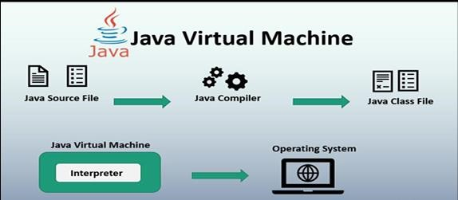
7.

jdb

→ Debugging (find errors)

Easy Comparison

Component Use
JVM Run program (execute bytecode)
JRE Environment to run program
JDK Develop + run program

Short Exam Tip
JVM executes Java program
JRE provides environment
JDK provides tools to develop Java

Q-4️: Write a short note on compiling and executing basic java program.
Ans: Steps:
Step 1: Save the program with .java extension (Note: Name of the program must be same as the name of the class)
Step 2: Open the command prompt and compile your program javac hello.java (where hello.java is the name of your file)
Step 3: Execute/run the program java hello Output: hello

Q-5️ Write a short note on java IDE
What is IDE?
- IDE stands for Integrated Development Environment
- It is a software used to write, compile, run, and debug programs
Example: NetBeans, Eclipse

NetBeans IDE
- It supports languages like:
o Java o PHP o C, C++ Features:
- Uses javac compiler (from JDK)
• Easy to develop Java applications
- Has built-in support for:
- MySQL
o Oracle database
- Beginner friendly (simple interface)
- Takes more time to start

Eclipse IDE
- It is an open-source IDE
- Supports many languages:
- Java
- C, C++
O Python
- PHP
o JavaScript Features:
- Uses its own compiler (not only javac)
- Shows more errors and warnings
- Fast loading (opens quickly)
- Needs extra tools for enterprise apps
- Has many windows for development
- Needs setup for database (JDBC)
- Not beginner friendly compared to NetBeans

NetBeans vs Eclipse (Easy Table)
Feature | NetBeans Eclipse
Easy to use | Yes (Beginner) No (Advanced)
Speed | Slow Fast
Compiler | javac Own compiler
Feature NetBeans Eclipse
Database support Built-in Need setup

Short Exam Tip
IDE is used to write and run Java programs
NetBeans is easy for beginners
Eclipse is faster and more advanced

Q-6: Data Types in Java (Simple Answer)
What is Data Type?
- Data type means type of data stored in a variable Example: number, decimal, character, true/false

Types of Data Types in Java
Integer Types (Whole Numbers)
- Used to store integer values (no decimal)
- Types:
Type Size Range byte 8 bit -128 to 127 short 16 bit -32,768 to 32,767 int 32 bit large values long 64 bit very large values

Floating Point Types (Decimal Numbers)
- Used for decimal values
Type Size Use
float 32 bit small decimal double 64 bit large decimal
Example: 3.14, 5.67

Character Type
- char is used to store a single character Type Size char 16 bit
Example: 'A', 'B'

Boolean Type
- Used for true or false values
Type Value
boolean true / false

Short Exam Tip
Integer → whole numbers
Float/Double → decimal numbers
Char → character
Boolean → true/false

Q-7: What is ADT? (Simple Answer)
ADT (Abstract Data Type)
- ADT stands for Abstract Data Type
- It defines:
What operations to perform
Not how to perform

Key Points
- It does not show implementation details
- It gives only the idea or model
- It hides internal working

Examples
- List
- Stack
- Queue

Simple Understanding
ADT = what to do, not how to do

Short Exam Tip
ADT defines operations without implementation
Examples: Stack, Queue, List

  - Write a short note on java tokens
Ans:
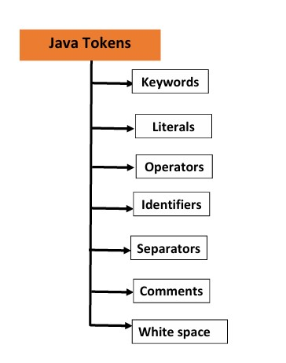
  - Write a short note on Operators in java
What is Token?
- Token is the smallest unit of a Java program
- It is identified by the Java compiler
Example: keywords, variables, operators

Types of Java Tokens
Java has different types of tokens:

Keywords
- Keywords are reserved words
- Their meaning cannot be changed
Examples:
int, class, if, else, enum

Literals
- Literals are constant values
Types:
- Integer → 10, 20
- Float → 2.5, 6.1
- String → "hello"

Operators
- Operators are symbols used for operations
Examples:
+, -, *, /

Identifiers
- Identifiers are names of variables, classes, or functions
Example: int age; → age is identifier

Separators
- Used to separate parts of program
Examples:
, ; ( ) { } [ ]

Comments
- Comments are not executed
- Used for explanation
Types:
- Single line → // comment
- Multi-line → /* comment */

Whitespace
- Used for spacing
- Includes: o Space o Tab o New line

Short Exam Tip
Token = smallest unit of program
Types: Keyword, Literal, Operator, Identifier, Separator, Comment, Whitespace

What is Operator?
- An operator is a symbol used to perform operations on variables or values

- Arithmetic Operators
  - Used for mathematical operations Operators: + - * / %
Example:
int a = 10, b = 5;

System.out.println(a + b); // 15
System.out.println(a - b); // 5
System.out.println(a * b); // 50
System.out.println(a / b); // 2
System.out.println(a % b); // 0

- Relational Operators
  - Used to compare values
  - Output is true or false Operators: > < == != >= <=
Example:
int a = 10, b = 5;

System.out.println(a > b); // true
System.out.println(a < b); // false
System.out.println(a == b); // false
System.out.println(a != b); // true

- Logical Operators
  - Used for logical conditions Operators: && || !
Example:
int a = 10, b = 5;

System.out.println(a > 5 && b < 10); // true
System.out.println(a < 5 || b < 10); // true
System.out.println(!(a > b)); // false

4️. Assignment Operators
  - Used to assign values Operators: = += -= *= /= Example:
int a = 10;

a += 5; // a = a + 5
System.out.println(a); // 15

5️. Conditional (Ternary) Operator
- Used as short if-else
Syntax:
condition ? value1 : value2;
Example:
int a = 10, b = 5;

int max = (a > b) ? a : b;
System.out.println(max); // 10

6️. Increment / Decrement
- Used to increase or decrease value by 1 Operators: ++ --
Example:
int a = 5;

a++;
System.out.println(a); // 6

a--;
System.out.println(a); // 5

7️. Bitwise Operators
- Used for binary (bit-level) operations Operators: & | ^ ~ Example:
int a = 5, b = 3;

System.out.println(a & b); // 1
System.out.println(a | b); // 7

8️. nstanceof Operator
- Checks object type
Example:
String name = "Java";

System.out.println(name instanceof String); // true
Or
Syntax: objectname=classname Example: test t1=new test();

9️. size of Operator:
❖ It is used to find the size of the variable or the type.
Syntax: Datatype (SIZE) Example: Float(SIZE);

Short Exam Tip
Arithmetic → math
Relational → compare
Logical → conditions
Assignment → store value

Q-10 Write a short note on Decision Control structures
  - Decision control structures are used to take decisions in a program.
  - It checks a condition and executes code based on true or false.
It helps to control the flow of program.

Types of Decision Control Structures

1 if Statement
• It executes block of code only if condition is true
Syntax:
if(condition) {
// code
}
Example:
int a = 10;

if(a > 5) {
System.out.println("a is greater"); }

2. if-else Statement
- It checks condition
- If true → run first block
- If false → run else block
Syntax:
if(condition) { // true block
} else {
// false block
}
Example:
int a = 3;

if(a > 5) {
System.out.println("a is greater");
} else {
System.out.println("a is smaller"); }

3. else-if Ladder
• Used to check multiple conditions
Syntax:
if(condition1) {
// code
} else if(condition2) {
// code
} else {
// code
}
Example:
int marks = 75;

if(marks >= 90) {
System.out.println("A grade");
} else if(marks >= 60) {
System.out.println("B grade");
} else {
System.out.println("C grade"); }

4️. switch Statement
• Used to select one option from many
Syntax:
switch(value) { case 1: // code break; case 2: // code break; default: // code }
Example:
int day = 2;

switch(day) { case 1:
System.out.println("Monday"); break; case 2:
System.out.println("Tuesday"); break; default:
System.out.println("Invalid"); }

Short Exam Tip if → single condition if-else → two conditions else-if → multiple conditions switch → many options

Q-11: What is Loop? Types of Looping Structures
What is Loop?
- A loop is used to repeat a block of code again and again
- It runs until a condition becomes false
Example: printing numbers from 1 to 10

Types of Looping Structures in Java
- for loop
- while loop
- do-while loop

- for Loop
  - Used when we know how many times to repeat
Syntax:
for(initialization; condition; increment/decrement) {
// code
}
Example:
for(int i = 1; i <= 5; i++) { System.out.println(i); }
Output: 1 2 3 4 5

- while Loop
  - Used when we don’t know exact number of times
Syntax:
while(condition) {
// code
}
Example:
int i = 1;

while(i <= 5) {
System.out.println(i);
i++; }
Output: 1 2 3 4 5

3. do-while Loop
• It runs at least one time even if condition is false
Syntax:
do { // code
} while(condition);
Example:
int i = 1;

do {
System.out.println(i);
i++;
} while(i <= 5);
Output: 1 2 3 4 5

Difference Between Loops Loop Condition Check Use for Before loop Known count while Before loop Unknown count do-while After loop Run at least once

Short Exam Tip
Loop is used to repeat code Types: for, while, do-while do-while runs at least one time

Q-12: Write a short note on jumping statements in java
- Jumping statements are used to transfer control of program from one place to another
- They help to change normal flow of execution

Types of Jumping Statements

- break Statement
  - It is used to stop the loop or switch statement immediately
Example:
for(int i = 1; i <= 5; i++) {
if(i == 3) {
break;
}
System.out.println(i); }
Output: 1 2

- continue Statement
  - It is used to skip current iteration and continue next loop Example:
for(int i = 1; i <= 5; i++) {
if(i == 3) {
continue;
}
System.out.println(i); }
Output: 1 2 4 5

- return Statement
  - It is used to exit from method
  - It can also return a value Example:
class Test {
static int add(int a, int b) {
return a + b;
}

public static void main(String args[]) {
System.out.println(add(2,3));
}
}
Output: 5

Short Exam Tip break → stop loop continue → skip iteration return → exit method

Q-13 Write a short note on typecasting
• Typecasting means converting one data type into another data type

Types of Typecasting

- Implicit Typecasting (Automatic)
  - It is done automatically by Java
  - Converts smaller data type into bigger data type
  - No data loss Example: int a = 10; double b = a; // int → double System.out.println(b); // 10.0

- Explicit Typecasting (Manual)
  - It is done manually by programmer
  - Converts bigger data type into smaller data type
  - Data loss may happen Example:
double a = 10.5️; int b = (int)a; // double → int System.out.println(b); // 10

Important Points
  - Implicit casting is safe
  - Explicit casting may lose data (decimal part removed)

Short Exam Tip
Typecasting = changing data type
Implicit → automatic Explicit → manual

Q-14️: Arrays in Java (Simple Answer)
What is Array?
  - Array is a collection of elements of same data type
  - All elements share same name
  - Each element is accessed using index (position)
Index starts from 0

Advantages of Array
  - Code Optimization → Easy to store and manage data
  - Random Access → Access any element using index

Disadvantages of Array
  - Fixed Size → Size cannot change at runtime

Types of Array
  - One Dimensional Array (1-D)
  - Multi-Dimensional Array (2-D)
  - Jagged Array

1) One Dimensional Array (1-D)
• Array with only one row (single dimension) Syntax: int a[] = new int[5️];
Example:
import java.util.*;

class arr {
public static void main(String args[]) { int i;
int a[] = new int[5️];
Scanner sc = new Scanner(System.in);

for(i = 0; i < 5️; i++) {
System.out.println("Enter array elements"); a[i] = sc.nextInt();
}

for(i = 0; i < 5️; i++) {
System.out.println("Array ele " + a[i]);
}
}
}

2) Two Dimensional Array (2-D)
- Stores data in rows and columns (matrix form)
- Total elements = rows × columns

Syntax:
int a[][] = new int[2][3]; Declaration of array: datatype[][] arrayname OR
datatype arrayname[][]

Example:
import java.util.*;

class arr {
public static void main(String args[]) {
int i, j;
int a[][] = new int[2][3];
Scanner sc = new Scanner(System.in);

for(i = 0; i < 2; i++) {
for(j = 0; j < 3; j++) {
System.out.println("Enter array elements"); a[i][j] = sc.nextInt();
}
}

for(i = 0; i < 2; i++) {
for(j = 0; j < 3; j++) {
System.out.println("Array ele " + a[i][j]);
}
}
} }

3) Jagged Array
- Array of arrays
- Row size is fixed, but column size is different Example:
int a[][] = new int[2][]; a[0] = new int[3]; a[1] = new int[2]; Full Example:
import java.util.*;

class arr {
public static void main(String args[]) { int i, j;
int a[][] = new int[2][]; a[0] = new int[3]; a[1] = new int[2];

Scanner sc = new Scanner(System.in);

for(i = 0; i < 2; i++) {
for(j = 0; j < a[i].length; j++) {
System.out.println("Enter array elements"); a[i][j] = sc.nextInt();
}
}

for(i = 0; i < 2; i++) {
for(j = 0; j < a[i].length; j++) {
System.out.println("Array ele " + a[i][j]);
}
}
}
}

Short Exam Tip
Array = collection of same data type
Types: 1D, 2D, Jagged Index starts from 0

Q-14️: Command Line Arguments (Simple Answer)
- Command line argument is a value passed when running the Java program
- These values are given from the command prompt (console)
- They are used as input in the program
Arguments are stored in args[] array

Key Points
- Arguments are passed at runtime
- Stored in String array (args[])
- Index starts from args[0]

Example:
class cmd1 {
public static void main(String args[]) {
System.out.println(args[0]);
}
}

How to Run:
javac cmd1.java java cmd1 Hello
Output:
Hello

Explanation
- args[0] → first argument
- args[1] → second argument

MCQ Points
- Arguments passed at runtime → Command line arguments
- Starting index → args[0]

Short Exam Tip
Command line arguments are inputs given at runtime
Stored in args[] array
Access using args[0], args[1]

Unit 1 –Class Fundas (Part 2)
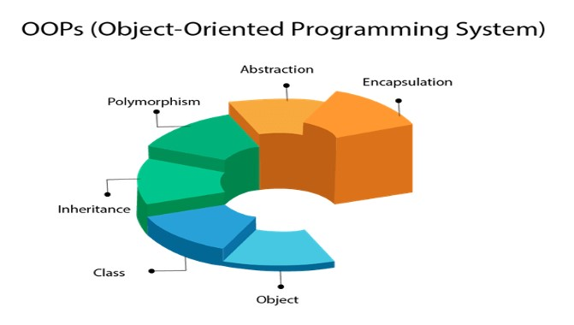
Q-1: Explain Class and Object
Class
- A class is a template or blueprint from which objects are created.
- It is a logical entity (not physical).
- A class defines data (variables) and behavior (methods).
- When we create a class, we create a new data type.

Object
- An object is an instance of a class.
- It is a real-world entity like pen, car, bike, etc.
- Each object has its own copy of variables.
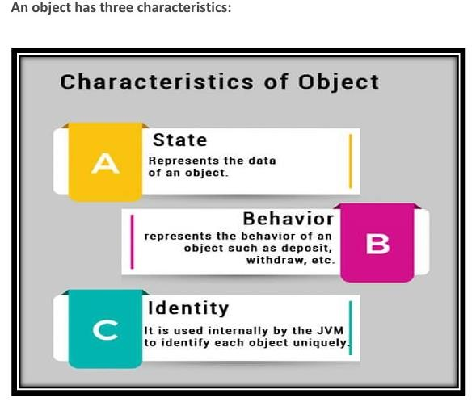

Key Points
- Class = group of objects having same properties
- Object = created from class
- Class defines structure, object uses it

Characteristics of Object
- State → data (value of object)
- Behavior → functionality (what object does)
- Identity → unique identity of object
Example:
Pen →
- State: color, name
- Behavior: writing

Syntax class ClassName {
int a;
int b;

void method() {
// code
}
}

Example
class student { int a = 10; int b = 20;

void add() {
System.out.println(a + b);
}

public static void main(String args[]) { student s = new student(); s.add();
}
}

MCQ Points
- Class → template
- Object → instance
- OOP main concept → class and object
- Object features → state, behavior, identity

Final Exam Line (VERY IMPORTANT)
A class is a blueprint and an object is its instance used to access data and methods.
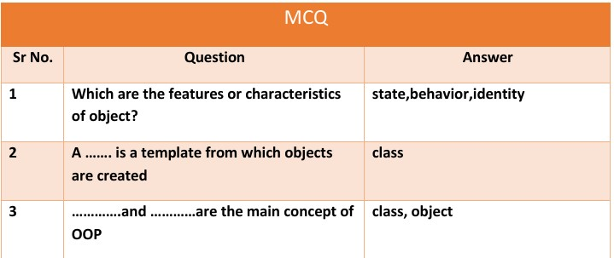
Q-2: Explain Encapsulation
Definition
- Encapsulation is one of the basic concepts of OOP
- It means wrapping data (variables) and methods together into one unit (class)

Key Points
- In encapsulation, data is hidden from outside classes
- Data can be accessed only through methods
- It is also called data hiding

How to Achieve Encapsulation
- Declare variables as private
- Use public getter and setter methods to access data

Advantages of Encapsulation
- Data can be secure (hidden)
- We can control how data is used
- Variables can be read-only or write-only
- Improves data safety and flexibility

Example
class test { private int roll;

public void get(int r) {
roll = r;
}

public void set() {
System.out.println(roll);
}
}

class enc {
public static void main(String args[]) { test t = new test(); t.get(1);
t.set();
}
}

MCQ Points
- Encapsulation = data + methods together
- Also called → data hiding
- Use → private + getter/setter

Final Exam Line
Encapsulation is the process of wrapping data and methods into a single unit and hiding data using private access.



Q-3: Inheritance (Simple Answer)
Definition
- Inheritance is a mechanism where one class gets properties and methods of another class
- It is an important concept of OOP

Terms in Inheritance
1. Class
• A blueprint to create objects
2. Super Class (Parent Class)
• The class whose properties are inherited
3. Sub Class (Child Class)
- The class that inherits another class

Advantage of Inheritance
- Reusability → We can reuse code of existing class
- Saves time and reduces code

Syntax
class SubClass extends SuperClass {
// code
}
extends keyword is used for inheritance

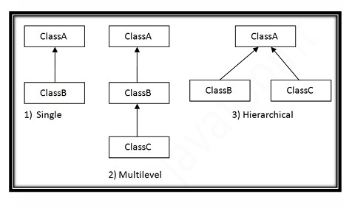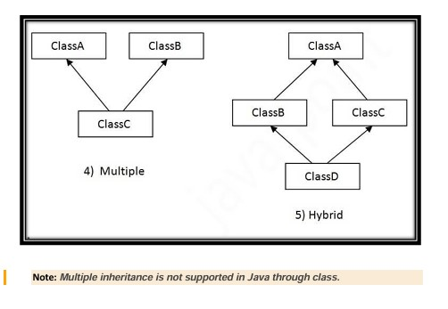

Types of Inheritance

1)
Single Inheritance

- One class inherits one class
Example:
class Animal {
void eat() {
System.out.println("Eating");
}
}

class Dog extends Animal {
void bark() {
System.out.println("Barking");
}
}

class test {
public static void main(String args[]) { Dog d = new Dog(); d.bark();
d.eat();
}
}

2) Multilevel Inheritance
• A class inherits another class, and that class is inherited by another Example:
class Animal {
void eat() {
System.out.println("Eating");
}
}

class Dog extends Animal {
void bark() {
System.out.println("Barking");
}
}

class BabyDog extends Dog {
void sleep() {
System.out.println("Sleeping");
}
}

class test { public static void main(String args[]) { BabyDog b = new BabyDog();
b.eat();
b.bark();
b.sleep();
}
}

3) Hierarchical Inheritance
- Multiple classes inherit one parent class Example:
class Animal {
void eat() {
System.out.println("Eating");
}
}

class Dog extends Animal {
void bark() {
System.out.println("Barking");
}
}

class Cat extends Animal { void sleep() {
System.out.println("Sleeping");
}
}

class test {
public static void main(String args[]) { Dog d = new Dog();
d.eat();
d.bark();

Cat c = new Cat(); c.eat();
c.sleep();
}
}

4️) Multiple Inheritance
- One class inherits more than one class
- Not supported in Java (with classes)
- Multiple inheritance is not supported in java by class. The reason is suppose A, B, and C are three classes. The C class inherits A and B classes. If A and B classes have the same method and you call it from child class object, there will be ambiguity to call the method of A or B class.
Example:

class A { void msg() {
System.out.println("Hello");
}
}
class B { void msg() {
System.out.println("Hi");
}
}
class C extends A, B {
public static void main(String args[]) { C c1 = new C(); c1.msg(); // Which msg() method will be called?
}
}
Will generate compile time error
Reason: Confusion (ambiguity)

5️) Hybrid Inheritance
- Combination of more than one type of inheritance
- Not fully supported using classes
- Hybrid inheritance is the combination of more than 1 type of inheritance.
Example:

class Animal { void eat() {
System.out.println("Eating");
}
}
class Dog extends Animal { // Single level inheritance void bark() {
System.out.println("Barking");
}
}
class Cat extends Animal { // (This is also single-level, not multilevel) void sleep() {
System.out.println("Sleeping");
}
}
public class Main {
public static void main(String args[]) { Cat c = new Cat(); c.eat();
c.sleep();
Dog d = new Dog(); d.bark();
d.eat();
}
}

Important Points
- Use extends keyword
- Java supports:
  - Single o Multilevel o Hierarchical
- Does NOT support:
  - Multiple (with classes)

Final Exam Line
Inheritance is a process where one class acquires properties and methods of another class for code reusability.
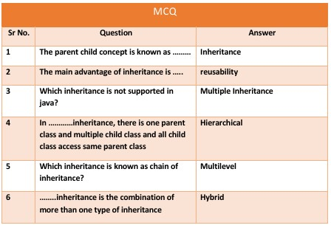

Q-3: Polymorphism (Simple Answer)
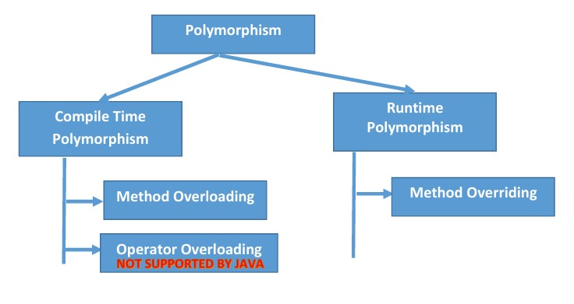
Definition
- Polymorphism means one action in many forms
- It comes from two words: o Poly → many o Morph → forms
So, polymorphism means many forms

Types of Polymorphism
- Compile Time Polymorphism
- Run Time Polymorphism

1) Compile Time Polymorphism
- Also called Static Polymorphism
- Achieved by Method Overloading
Method Overloading
- Same method name but different parameters
- Can change:
o Number of arguments o Type of arguments

Example:
class overload {
void add(int a, int b, int c) { System.out.println(a + b + c);
}

void add(int a, int b) { System.out.println(a + b);
}
}

class method1 {
public static void main(String args[]) { overload o1 = new overload();
o1.add(2, 3, 4);
o1.add(1, 2);
}
}

2) Run Time Polymorphism
- Also called Dynamic Polymorphism
- Achieved by Method Overriding
Method Overriding
- Same method in parent and child class
- Method call is decided at runtime
Child class method is executed

Example:
class A { void run() {
System.out.println("Hello");
}
}

class B extends A { void run() {
System.out.println("Hi");
}
}

class sam {
public static void main(String args[]) {
B b1 = new B(); b1.run();
}
}

Key Points
- One method → many forms
- Overloading → compile time
- Overriding → run time

Final Exam Line
Polymorphism is a concept where one method can perform different actions in different situations.
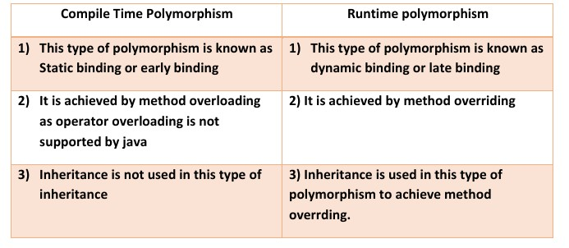

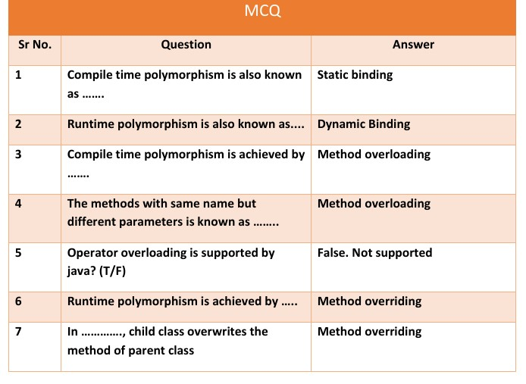
Q-4️: Constructor (Simple Answer)
Definition
- A constructor is a special method
- It has the same name as the class
- It is automatically called when object is created

Rules of Constructor
- Constructor name must be same as class name
- It has no return type (not even void)
- It cannot be:
- abstract
- static
- final
- synchronized

Types of Constructor
- Default Constructor
- Parameterized Constructor

1) Default Constructor
• A constructor with no parameters Example:
class A {
A() {
System.out.println("Default constructor");
}
}

class test {
public static void main(String args[]) {
A a1 = new A();
}
}

2) Parameterized Constructor
- A constructor with parameters (arguments)
Example:
class A {
int roll;

A(int r) { roll = r;
}

void display() {
System.out.println(roll);
}
}

class test {
public static void main(String args[]) {
A a1 = new A(10);
a1.display();
}
}

Key Points
- Constructor is used to initialize object values
- Called automatically when object is created
- Helps to set initial data

Final Exam Line
Constructor is a special method used to initialize objects and is automatically called when an object is created.

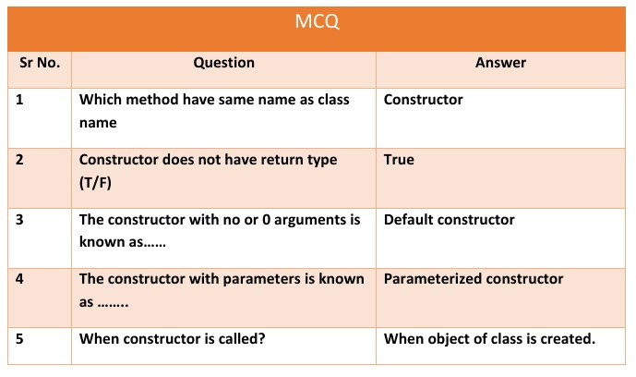

Q-5️ Write a short note on Constructor overloading

Q-5️: Constructor Overloading (Simple Answer)
Definition
- Constructor overloading means having multiple constructors with same name but different parameters
- It is used to initialize objects in different ways

Key Points
- Constructor name is same as class name
- Parameters must be different (number or type)
- Helps to create different types of objects

Example

class cons {
int a, b;

cons() {
System.out.println("Hello");
}

cons(int a1) { a = a1;
}

cons(int a1, int b1) { a = a1;
b = b1;
}

void display() {
System.out.println(a);
System.out.println(b);
}
}

class consoverload {
public static void main(String args[]) { cons c = new cons(); cons c1 = new cons(10);
cons c2 = new cons(10, 11);

c1.display(); c2.display();
}
}
Explanation
- cons() → default constructor
- cons(int a1) → one parameter
- cons(int a1, int b1) → two parameters
Same name but different parameters → constructor overloading

Final Exam Line
Constructor overloading is the process of defining multiple constructors with same name but different parameters in a class.

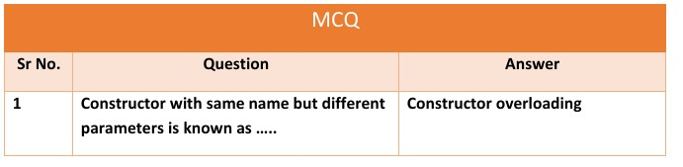
Q-6️: Static and Non-Static Members in Java
Static Variables
- Static variable is declared using static keyword
- Only one copy is created
- It is shared by all objects of the class
- It is created at class level

Example:
class test {
static int a = 20;

void display() {
a++;
System.out.println(a);
}
}

class sample {
public static void main(String args[]) {
test t1 = new test(); test t2 = new test(); test t3 = new test();

t1.display();
t2.display(); t3.display();
} }
Output will be:
21
22 23
Same variable is shared by all objects

Non-Static Variables
- Non-static variable is declared without static keyword
- Each object has its own separate copy
- Values are not shared between objects

Example:
class test { int a = 20;

void display() {
a++;
System.out.println(a);
}
}

class sample {
public static void main(String args[]) {
test t1 = new test(); test t2 = new test(); test t3 = new test();

t1.display(); t2.display(); t3.display();
} }
Output will be:
21 21 21
Each object has its own variable

Key Difference
Static Non-Static
One copy Multiple copies
Shared by all objects Separate for each object
Class level Object level

Final Exam Line
Static members are shared by all objects, while non-static members have separate copies for each object.

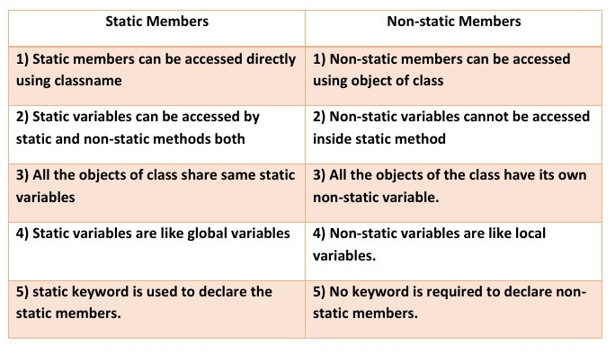
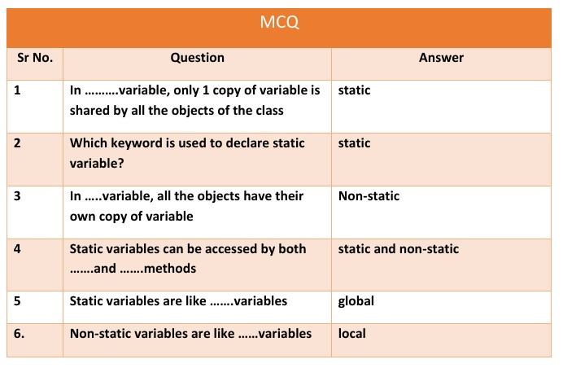

Q-7️: Varargs (Simple Answer)
Definition
- Varargs means variable number of arguments
- It allows a method to accept zero or more values
- Useful when we don’t know how many arguments will be passed

Key Points
- Varargs uses three dots (…) after data type
- It treats arguments like an array
- We can pass: o No value o One value o Many values

Syntax
return_type method_name(data_type... variableName) {
// code
}

Example
class varg { public void display(int... values) {
System.out.println("hello");

for(int i : values) {
System.out.println(i);
}
}
}

class B {
public static void main(String args[]) { varg a = new varg();

a.display(); // no argument
a.display(1, 2, 3, 4); // multiple arguments
a.display(12, 22); // two arguments
}
}

Explanation
- int... values → accepts multiple integers
- Works like an array (values[])
- Loop is used to print all values

Final Exam Line
Varargs allows a method to accept variable number of arguments using three dots
(…) .

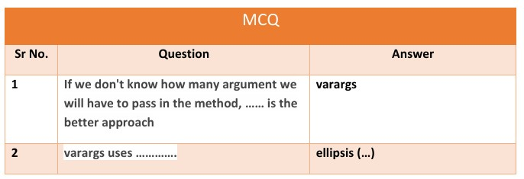

Q-8️: IIB Block in Java (Simple Answer)
Definition
- IIB stands for Instance Initializer Block
- It is used to initialize instance variables

Key Points
- It runs every time when object is created
- It is written inside class but outside methods
- It executes before constructor

Example
class iib {
int a;

// Instance Initialization Block
{
a = 10;
}

public void display() {
System.out.println(a);
}
}

class im {
public static void main(String[] args) {
iib i = new iib();
i.display();

iib i2 = new iib();
i2.display();
}
}

Explanation
- Block { a = 10; } is IIB
- It runs each time object is created
- So both objects get value a = 10

Final Exam Line
IIB is used to initialize instance variables and it runs every time an object is created.

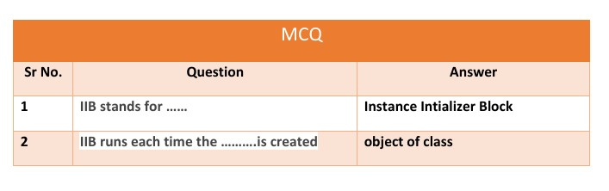

End of Unit 1

